Mounty-Python: Always look on the bright side of the board.
Architecture Documentation
Structure: arc42. Diagrams: C4 model (draw.io sources .drawio in this folder).
Sources: README.md, copilot instructions, AppHost.cs and the implementation.

1. Introduction and Goals
MountyPython manages orders in an SMT (Surface-Mount Technology) manufacturing environment. It supports creating, editing, searching and deleting Orders, Boards and Components, and downloading an order to simulate a hand-off to a production line. Motto: Always look on the bright side of the board.

1.1 Requirements overview
- An Order contains one or more Boards (with quantity); a Board consists of one or more Components.
- Order: Name, Description, Order Date. Board: Name, Description, Length, Width. Component: Name, Description, Quantity.
- Customers see available boards, create/edit/cancel and see only their own orders.
- Managers edit/delete boards, see all orders and move an order to Processing, Completed or Cancelled.
- An order may be changed or cancelled only while its status is Created; items (boards, quantities) are editable in that state only.
- Order download as JSON; web UI behind login; persistence across restarts; logging; unit tests; CI/CD; containerization.

1.2 Quality goals
Priority | Goal | Motivation
1 | Time-to-market / low cost | More than a prototype, low development, maintenance and running cost, no paid licenses.
2 | Maintainability | Vertical slices, DDD, CQRS-style commands/queries, tests (xUnit v3 + AwesomeAssertions).
3 | Security | Keycloak (OIDC/JWT), role-based access (customer vs manager), ownership guard on orders.
4 | Resilience & observability | Retries, fail-fast, timeouts, health checks, OpenTelemetry, Serilog.
5 | Usability | Mobile-first Angular Material UI.

1.3 Stakeholders
Role | Expectation
Customer | Simple ordering of boards, sees only own orders, real-time status updates.
Manager | Maintains catalog, controls order lifecycle, overview of all orders.
Development team | Clear structure, fast feedback through CI, easy local start via Aspire.
Operations | Reproducible provisioning on Azure, monitoring.

2. Architecture Constraints
Constraint | Background
Technology: .NET 10 / C# 14, ASP.NET Core Minimal APIs, EF Core, PostgreSQL | Chosen stack, cross-platform.
Orchestration: .NET Aspire (AppHost) | Single composition root for infrastructure and service discovery.
Identity: Keycloak | Free identity provider instead of Azure AD B2C.
Messaging: RabbitMQ with Rebus | Rebus instead of MassTransit (licensing).
No MediatR / AutoMapper / FluentAssertions | License costs; hand-written commands, consumers and DTO mapping; AwesomeAssertions used.
Frontend: Angular (NgModule based), Angular Material, NgRx, Signal Forms, Node 24 | Mobile-first, state management via NgRx.
Hosting: Azure Container Apps, GitHub, GitHub Actions | Free-tier friendly cloud deployment.
Domain model changes require approval | Team convention (copilot-instructions).

3. Context and Scope

3.1 Business context
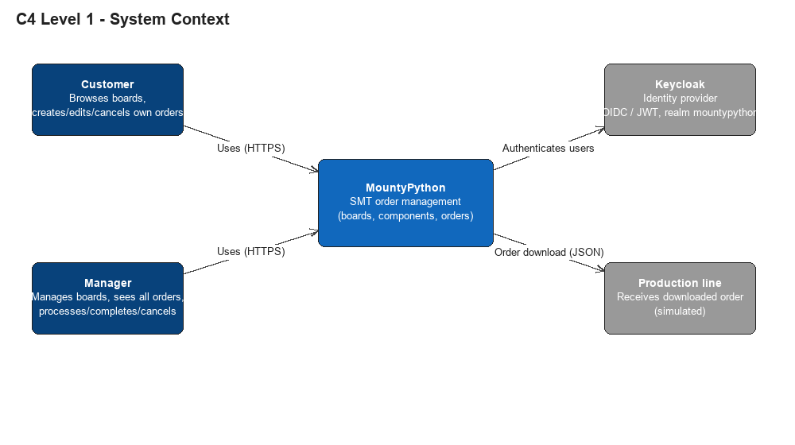
Partner | Input | Output
Customer | Create/edit/cancel orders, search boards | Order status, real-time notifications
Manager | Maintain boards, change order status | All orders, notifications
Keycloak | Credentials | JWT access tokens (audience mountypython-api)
Production line (simulated) | - | Downloaded order file (JSON)

3.2 Technical context
- Browser to Angular app over HTTPS; locally on port 4200 with dev proxy (src/proxy.conf.js), in Azure via YARP.
- API paths: /api/catalogs (Inventory), /api/operations (Operative), notification and SignalR paths, plus Keycloak paths.
- Services to PostgreSQL through Npgsql; services to RabbitMQ through Rebus; all services validate JWTs issued by Keycloak.

4. Solution Strategy
Goal | Approach
Fast delivery, low complexity | Aspire provisions all resources; shared Commons library for logging, repository, messaging, security.
Independent evolution | 3 microservices (Inventory, Operative, Notification) with own databases (Inventory, Operative).
Loose coupling | Event-driven architecture: domain events published through Rebus/RabbitMQ; consumers subscribe per event type.
Maintainability | Onion/Clean architecture with vertical slices; Commands/Queries/Consumers per file with their interface; DDD domain model with validators.
Security | Keycloak realm import (import.json), JWT bearer, manager/customer authorization, ownership guard.
Resilience | ServiceDefaults: service discovery, resilient HttpClient (retry, fail-fast, timeout), health checks.
Quality | TDD, xUnit v3 on Microsoft Testing Platform, CI on every push; Playwright E2E planned.
Operations | GitHub Actions: dev-branch deploys to development, main to production; automatic versioning and tagging.

5. Building Block View

5.1 Level 1 - Containers (C4)
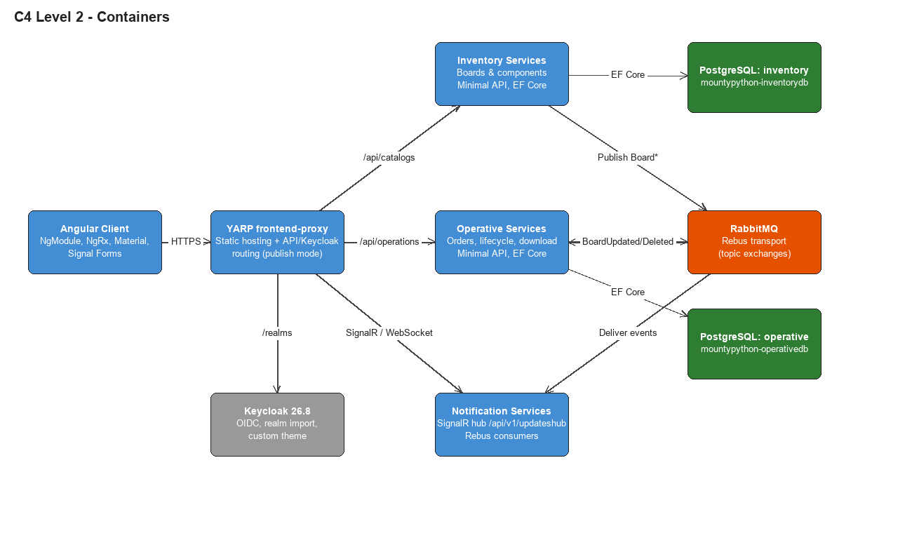
Building block | Responsibility
MountyPython.AppHost | Composition root: PostgreSQL, RabbitMQ, Keycloak, three services, Angular app, YARP (publish).
MountyPython.ServiceDefaults | OpenTelemetry, service discovery, resilient HttpClient, /health and /alive (development).
Inventory.Services | Catalog of Boards and Components: CRUD, search (case and accent insensitive), publishes BoardCreated/Updated/Deleted.
Operative.Services | Orders: create, update (name/description and items while Created), start processing, complete, cancel, download; consumes board events.
Notification.Services | Consumes order and board events and pushes updates to clients through the SignalR hub.
Commons (Backend/Shared) | Domain base types, repository, publisher, logging, JWT/authorization, exception handling, JSON defaults.
Angular client | Feature modules mirroring backend slices (inventory, operations); NgRx stores for boards, orders and auth.

5.2 Level 2 - Service internals
- Features/<area>: Commands, Queries, Consumers, Domain and a Map...Endpoints module that creates tagged route groups.
- Queries return aggregate DTOs; commands return domain entities which the endpoint maps to DTOs.
- Program.cs owns startup wiring (auth, validation, Rebus, DbContext, migrations, OpenAPI/Scalar in development).
- Each service owns its DbContext and migrations; MigratorHostedService<TContext> applies migrations on startup.

6. Runtime View

6.1 Create order
- Customer submits name, date and items (board snapshot with components, quantity) in the Angular form.
- NgRx effect calls POST /api/operations/orders; CreateOrderCommand builds board/component snapshots and the Order aggregate.
- Repository saves and publishes OrderCreatedEvent; Notification pushes the update to connected clients.

6.2 Edit order (status Created)
- Details/edit open an NgRx action that loads the full order by ID; the list only holds aggregates.
- The form allows adding/removing boards and changing quantities; PUT sends name, description and items.
- Order.UpdateItems rejects the change unless status is Created.

6.3 Board update propagates
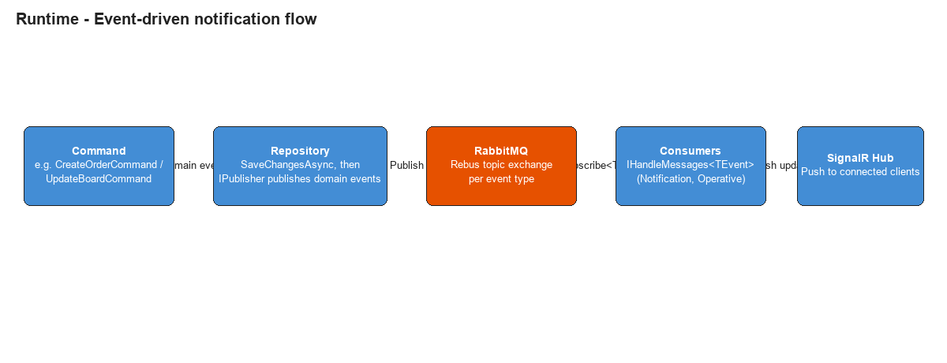
- Manager updates a board; components are matched by PK and updated in place.
- BoardUpdatedEvent is published; Operative and Notification consume it through their Rebus subscriptions.

6.4 Login
- Angular redirects to Keycloak (OIDC); the token is kept in session storage so refresh keeps the session; API calls carry the bearer token.

7. Deployment View
Environment | Description
Local | Aspire runs PostgreSQL (with pgAdmin), RabbitMQ (management), Keycloak (port 9001, realm import, theme bind-mount) as containers; services as processes; Angular dev server on 4200. Docker required.
Development (Azure) | Deployed from dev-branch to an Azure Container Apps environment (mountypython-dev), Azure PostgreSQL Flexible Server, YARP frontend-proxy serving the built client.
Production (Azure) | Promoted from main (tagged, verified commit) to mountypython-prod; same topology.

- Provisioning is generated by Aspire (no manual steps); publish-mode resource and route configuration must be preserved.
- Keycloak sits behind ACA HTTPS ingress; YARP builds https URLs to it.

8. Cross-cutting Concepts
Concept | Realization
Domain model | DDD aggregates (Order, Board) with value objects (OrderItem, Component), FluentValidation at API and domain level, domain events.
Persistence | EF Core + Npgsql via SetupNpgsqlServerDbContext; PostgreSQL unaccent for accent/case insensitive search.
Security | JWT bearer, manager/customer authorization, OrderOwnershipGuard; Scalar/OpenAPI development only.
Messaging | Rebus handlers auto-registered per assembly; events require explicit Subscribe<T>() per consuming service.
Logging & monitoring | Serilog, OpenTelemetry via ServiceDefaults, Azure Application Insights.
Error handling | Custom exception handler middleware mapping domain/validation/not-found errors.
Testing | xUnit v3 + AwesomeAssertions on Microsoft Testing Platform; Angular tests with Vitest.
Frontend | Mobile-first Material design, NgRx state, Signal Forms, styling in SCSS, global app-dialog class.
Mapping | Hand-written DTO mapping instead of AutoMapper.

9. Architecture Decisions
ID | Decision | Rationale
ADR-1 | Aspire for orchestration and provisioning | Single model for local and Azure; fewer manual steps.
ADR-2 | 3 microservices instead of a monolith | Aspire lowers cost; separate notification and business concerns.
ADR-3 | Rebus instead of MassTransit | License cost.
ADR-4 | Commands and Consumers instead of MediatR | License cost, simplicity.
ADR-5 | Keycloak instead of Azure AD B2C | Free, self-hosted, realm as code.
ADR-6 | YARP serves the Angular static app | BFF-style single entry point in Azure.
ADR-7 | Orders hold board snapshots | Orders remain stable if the catalog changes; items editable only while Created.
ADR-8 | Database per service, migrations on startup | Autonomy; zero-touch deployment.

10. Quality Requirements
Quality | Scenario | Measure
Security | Customer requests another customer's order | 404 Not Found (ownership guard)
Consistency | Order changed after processing started | Rejected by domain validation
Resilience | Downstream service slow or failing | Retry, fail-fast, and timeout from ServiceDefaults
Observability | Failure in production | Traces, metrics and logs in OpenTelemetry / Application Insights
Usability | Edit dialog on phone | Single-column mobile-first layout

11. Risks and Technical Debt
- Missing Rebus Subscribe<T>() calls silently stop consumers from running; add integration tests covering delivery.
- Board snapshots in orders can diverge from the catalog (intentional, but must be communicated).
- UpdateItems reuses OrderUpdatedNameOrDescriptionEvent; a dedicated event may be needed.
- Idempotent requests are planned but not fully implemented; horizontal scalability and E2E (Playwright) tests are 'if time allows'.
- Angular tests executed through Visual Studio Test Explorer fail on JIT configuration; use npx ng test.
- Circuit breaker covers HTTP only: AddStandardResilienceHandler (ServiceDefaults) protects HttpClient calls, but PostgreSQL and RabbitMQ/Rebus are not covered, and the services currently do not call each other over HTTP, so it protects little today.
- Circuit breaker defaults do not fit the traffic: it opens only after at least 100 requests in a 10s window (10% failure ratio, 5s break); tune MinimumThroughput (5-10), FailureRatio (about 0.5), SamplingDuration (about 30s) and BreakDuration (15-30s) per client.
- No observability for resilience: log and alert on circuit OnOpened/OnHalfOpened/OnClosed, expose an open-circuit metric and a degraded health check.
- Messaging resilience is implicit: configure Rebus retries (max delivery attempts), the error queue and alerting on its depth explicitly.
- Events can be lost on a broker outage: Publisher publishes right after SaveChangesAsync; a transactional outbox is the proper fix.
- No fallback behaviour defined: notifications down must not fail orders (fire-and-forget), Keycloak down should fail fast with 503, and the UI should show a retry message.
- No tests for resilience: add unit tests with a failing HttpMessageHandler asserting the circuit opens, and optionally a chaos test stopping RabbitMQ locally.

12. Glossary
Term | Meaning
SMT | Surface-Mount Technology, PCB assembly process.
Board | Printed circuit board design with its components.
Component | Part placed on a board with a quantity.
Order | Request to produce boards in given quantities; status Created, Processing, Completed or Cancelled.
Aspire | .NET application host for orchestration and provisioning.
Rebus | Service bus library used over RabbitMQ.
YARP | Yet Another Reverse Proxy.
C4 / arc42 | Documentation models used for the diagrams and the structure of this document.

